Hello Year 5, I would like you to use the internet to explore the rivers of the world. Can you find the information to complete the table below?

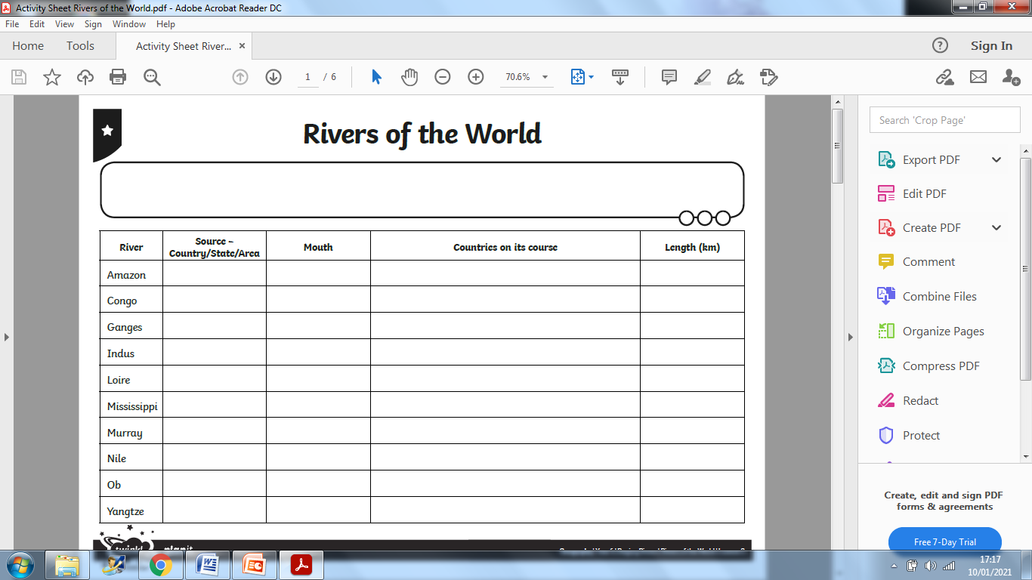 Remember- The **source** is the place the river starts.

The **mouth** is where the river flows into the sea.